ST ANDREW’S JUNIOR COLLEGE

JC 2 Preliminary Examination
CHEMISTRY 9647/03
Higher 2 13 September 2010

Paper 3 Free Response 2 hours

Candidates answer on separate paper.
Additional Materials: Answer paper, Graph Paper, Data Booklet

READ THESE INSTRUCTIONS FIRST
Write your name and civics group on all the work you hand in.
Write in dark blue or black pen on both sides of the paper.
You may use a soft pencil for any diagrams, graphs or rough working.
Do not use staples, paper clips, highlighters, glue or correction fluid.

Answer any four questions.
A Data Booklet is provided.
You are reminded of the need for good English and clear presentation in your answers.

The number of marks is given in brackets [ ] at the end of each question or part question.
At the end of the examination, fasten all your work securely together.

This question paper consists of 10 printed pages.

Answer any four questions.

1 (a) Hydrolysis of a lipid (containing multiple ester linkages) produced the following fatty acids.

Structure I CH₃(CH₂)₄CH=CHCH₂CH=CH(CH₂)₇COOH
Structure II CH₃CH₂CH=CHCH₂CH=CHCH₂CH=CH(CH₂)₇COOH

- In an experiment, hot acidified potassium manganate(VII) was used to oxidise Structure I. Write the structural formulae of all organic products formed during the oxidation.

(ii) What is meant by the term cis-trans isomerism? How many cis-trans isomers are present in Structure I? Draw any 2 possible cis-trans isomers.

(iii) State the physical state of this lipid at room temperature. Explain your answer.
[9]

(b) Suggest a possible identity for each of the organic compounds A-E below. Explain your reasoning and write balanced equations for the reactions involved where possible.

(i) A, C₁₁H₁₄O₂ is a neutral compound. Hydrolysis of A gives B, C₇H₆O₂ which is a white precipitate and C, C₄H₁₀O which does not decolourise acidified potassium manganate(VII) on heating.

(ii) D, C₄H₁₀O₂ reacts with 2 moles of sodium metal, but not with solid sodium carbonate. On boiling under reflux with aqueous potassium manganate(VII), D gives a compound, E, C₄H₆O₃. E reacts with alkaline aqueous iodine to give a yellow precipitate and evolves carbon dioxide when solid sodium carbonate is added.
[11]

[Total: 20]

2 (a) Explain each of the following observations as fully as you can.
(i) Phenylalanine, C₆H₅CH₂CH(NH₂)COOH, is readily soluble in water whereas phenylamine is insoluble.

- Trimethylamine, (CH₃)₃N, has a lower boiling point than dimethylamine, (CH₃)₂NH.

- An aqueous solution of trimethylamine is more basic than phenylamine.
[9]

(b) When 20.0 cm³ of a solution of trimethylamine was titrated against 0.0300 mol dm⁻³ hydrochloric acid, the following pH readings were obtained:
Volume / cm³ | pH
0 | 12.4
5 | 10.6
10 | 10.2
15 | 10.0
20 | 9.7
25 | 9.4
28 | 9.2
30 | 8.9
32 | 8.5
34 | 3.4
35 | 3.0
40 | 2.5
45 | 2.3
50 | 2.2

(i) Plot a graph of these results with pH on the y axis and volume of hydrochloric acid added on the x axis. Label and comment on the shape of the curve before, at and after neutralisation.

- Label the equivalence point on your graph for b(i) and suggest a suitable indicator from the following list. Explain your choice.
Indicator | pH at which colour changes
Methyl orange | 3.2 – 4.4
Methyl red | 4.8 – 6.0
Bromothymol blue | 6.0 – 7.6
Phenol red | 6.8 – 8.4
Phenolphthalein | 8.2 – 10.0
[7]
[Turn over
2 (c) A sodium salt of glutamic acid, monosodium glutamate (MSG), is a flavour enhancer.
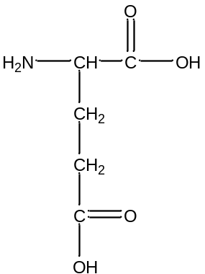Glutamic acid

(i) Draw structural formulae of the products of the reactions between glutamic acid and
I aqueous NaOH
II aqueous HCl

(ii) Draw the structural formula of a dipeptide formed between glutamic acid and phenylalanine, showing the ionic form in which it would exist at pH 10.
[4]

[Total: 20]

3 (a) Iron(III) chloride is a dark brown solid which dissolves in water to give an acidic solution. This solution is used to etch, i.e. dissolve, unwanted copper from printed circuit boards. When a copper-coated printed circuit board is immersed in aqueous iron(III) chloride, the solution turns greenish blue.

(i) Explain, with the aid of an equation, why aqueous iron(III) chloride is acidic.

(ii) Use the Data Booklet to explain why iron(III) chloride etches copper. Give a relevant equation to explain the greenish blue solution observed.

(iii) Suggest what happens to the overall E⁰ value if the thickness of the copper coating is increased.
[5]

(b) Anhydrous aluminium chloride behaves similarly as anhydrous iron(III) chloride in that they sublime readily when heated. When 1.56 g of aluminium chloride was placed in an evacuated vessel of volume 1.00 dm³ at 180⁰C, the pressure produced was 32.3 kPa.

(i) Calculate the apparent relative molecular mass of the aluminium chloride under the stated conditions.

(ii) In the vapour phase, aluminium chloride partially exists as a dimer. Using your answer obtained for b(i), calculate the percentage of the dimer under the stated conditions.

- Suggest a reason why the dimerisation process of aluminium chloride is exothermic.

(iv) Predict, giving a reason in each case, the effect on the proportion of dimer in the equilibrium mixture if

I the pressure is lowered,
II the temperature is lowered.
[7]

[Turn over
3 (c) Compound A, C₁₄H₁₉NO₂, is the active substance in Cayenne pepper and it is basic. On heating with aqueous sodium hydroxide, compound A produces 2 compounds. One of them is compound B, C₇H₈NO⁻Na⁺. Compound B reacts with excess CH₃Cl to give compound D, C₁₁H₁₈NO⁺Cl⁻.

The other compound from A gives compound C, C₇H₁₂O₂, upon acidification.
Compound C liberates carbon dioxide from aqueous sodium hydrogencarbonate, and catalytic hydrogenation of C gives G, C₇H₁₄O₂. When C is heated with acidified potassium manganate(VII), HOOCCH₂COOH and H, C₄H₈O₂, are obtained. H can be synthesised from 2-bromopropane in a two-step reaction.

Compound B can be synthesised via the following sequence of reactions.

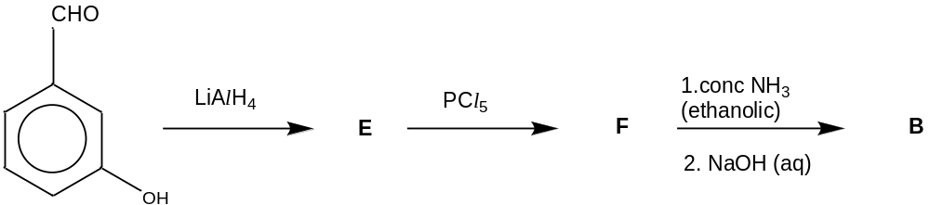

Suggest a structure for each lettered compound, and explain the reactions involved.
[8]

[Total: 20]

4 (a) With reference to CaCO₃, define the term standard enthalpy change of formation. [1]

(b) When 0.25 g of calcium was dissolved in an excess of hydrochloric acid in an insulated flask, the temperature rose by 9.7⁰C.
Ca(s) + 2HCl(aq) ➔ CaCl₂(aq) + H₂(g)
Separate experiments showed that the insulated flask and its contents required 400 J to raise the temperature by 1⁰C.

(i) Calculate the heat evolved in the experiment.

(ii) Hence calculate the enthalpy change of reaction per mole of calcium.

(iii) In a similar experiment, solid calcium carbonate reacted with an excess of hydrochloric acid and the enthalpy change was found to be –95.0 kJ per mole of calcium carbonate. Using the information given and your result from (b)(ii), calculate the standard enthalpy change of formation of calcium carbonate . ΔH_{f}º(H₂O) = -286 kJ mol⁻¹
ΔH_{c}º(C) = -394 kJ mol⁻¹
[5]

(c) Magnesium carbonate decomposes on heating.
MgCO₃(s) ➔ MgO(s) + CO₂(g)
ΔH^{ө} = +117 kJ mol⁻¹; ΔS^{ө} = +175 J mol⁻¹ K⁻¹

(i) Why does the entropy increase when magnesium carbonate decomposes?

(ii) Calculate the standard Gibbs free energy change, ΔG^{ө}, for the decomposition of magnesium carbonate. Comment on the spontaneity of the decomposition of magnesium carbonate at room temperature.

(iii) Assuming that ΔH^{ө} and ΔS^{ө} for the reaction are independent of temperature, calculate the temperature at which the decomposition reaction becomes feasible.
(iv) Compare the ease of thermal decomposition of magnesium carbonate with barium carbonate.
[8]
[Turn over
4 (d) Suggest a simple chemical test to distinguish between each pair of compounds.
For each test, give reagents and conditions, and state what would be seen with each compound.

(i)
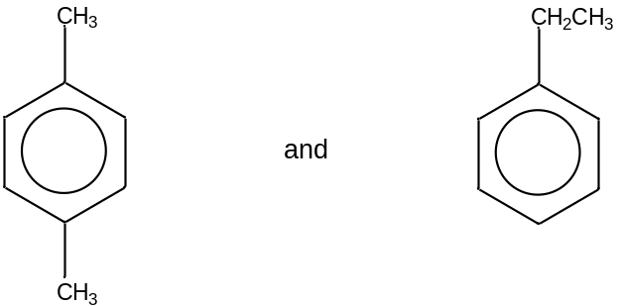

(ii)
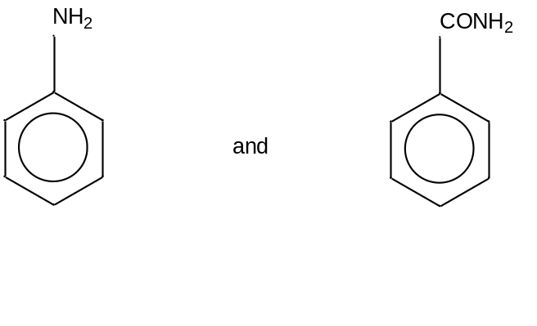

(iii)
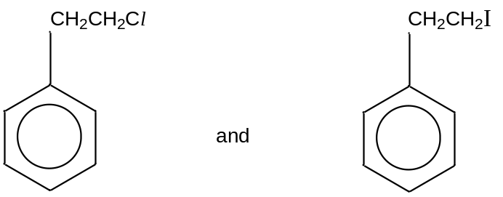

[6]

[Total: 20]

5 (a) The dissociation reactions and K_{a} values of carbonic acid are given below.

H₂CO₃ HCO₃⁻ + H⁺ K_{a1} = 4.2 x 10⁻⁷ mol dm⁻³
HCO₃⁻ CO₃² ⁻ + H⁺ K_{a2} = 4.8 x 10⁻¹¹ mol dm⁻³

0.10 mol dm⁻³ aqueous NaOH is added slowly to 20.0 cm³ of carbonic acid and the change in pH is followed and shown below.

pH
40
20
0
30
10
A
B
x

x
x
x

x

Vol of aqueous NaOH added / cm³

(i) Calculate the initial pH of the carbonic acid, stating any assumptions you make.

(ii) Calculate the pH at the first equivalence point, A.

(iii) What is the pH at point B? Give a reason for your answer.
[6]

[Turn over
5 (b) Maintenance of pH is vital to the cells of all living organisms because enzyme activity is influenced by pH. For instance, protection from harmful pH change in the blood plasma is provided by the hydrogencarbonate/carbonic acid system (HCO₃⁻/H₂CO₃). At 37⁰C, the temperature of the human body, pH of blood plasma is 7.4.

(i) Explain, with relevant equations, how the hydrogencarbonate/carbonic acid system regulates the pH of blood plasma.

(ii) Calculate the ratio of [HCO₃⁻]/[H₂CO₃] for maintaining the optimum pH of blood plasma.
[4]

(c) Describe two differences in physical properties between transition metals and a s-block metal such as magnesium, suggesting reasons for these differences based on their atomic structures. [3]

(d) The oxidation of manganese(IV) oxide in alkaline solution in air produces green manganate(VI) ion, MnO₄²⁻. When manganate(VI) is added to a dilute acid, a purple solution and dark brown solid manganese(IV) oxide reforms.
When a small amount of manganese(IV) oxide is added to aqueous hydrogen peroxide, the latter decomposes to produce oxygen and water.

(i) Write a balanced equation for the production of manganate(VI) ion.

(ii) With the aid of an equation, explain the type of reaction in the production of the purple solution and the brown solid.

(iii) Explain why manganese is able to exhibit variable oxidation states.

(iv) Explain the role of manganese(IV) oxide in the decomposition of hydrogen peroxide.
[7]

[Total: 20]

******** End of Paper ********

